Timeline
3000 B.C. | 1200 B.C. | 750 B.C. | 770 B.C. | 776 B.C. | 600 B.C. | 500 B.C. | 431 B.C. | 334 B.C. | 146 B.C.
Minoan Civilization begins on Crete | The Trojan Wars | Greeks set sail to set up colonies | First Greek alphabet created | First Olympic Games | First Greek coins are used | Democracy used in Athens | The Peloponnesian Wars begin | Alexander the Great  conquests | Greece becomes part of the Roman Empire
 | Key Vocabulary
acropolis | A large hill where city residents sought shelter and safety in times of war. Also, a meeting place for discussing issues.
amphitheatre | Outdoor theatre with seats on all sides where singing, dancing and even sacrificing took place.
chiton | The chiton was a single sheet used as clothing wrapped around the body.
democracy | A system of government in which citizens are able to vote in order to make decisions.
Olympics | Athletes competing against each other. Began in Olympia and included religious festivals in honour of Zeus.
Parthenon | A former temple on the Athenian Acropolis dedicated to the goddess Athena.
philosophy | The practice of asking big questions with no clear/single answer. It means the ‘love of wisdom’.
pyxis | 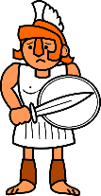  A cylindrical box with a separate lid used to store trinkets, ornaments or cosmetics.
Trojan Horse | Wooden horse constructed by Greeks to obtain entry into the city of Troy. Soldiers hid inside and then sprang out!
vase | Pots made on a potters’ wheel often painted with aspects of daily life from which historians have learned from.
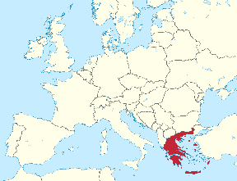
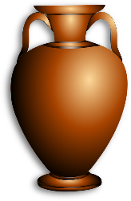
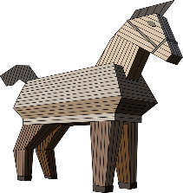
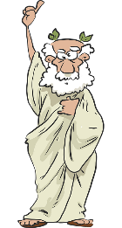
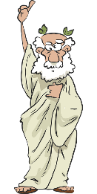
The Peloponnesian Wars took place between the city-states of Sparta and Athens between 431-404 B.C. The Athenians stood for democracy but lost to the Spartans, leaving Athens bankrupt and destroyed.
Greece
(Europe)
Ancient Greeks
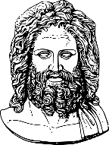
Archimedes (287-212 B.C.)
Mathematician and philosopher who found a way of measuring water by placing an object in it and seeing how far it rose (hydrostatics). He jumped out of the bath and shouted ‘Eureka!’ meaning ‘I found it!’
Alexander the Great (356-332 B.C.)
King of Macedonia who conquered Greece, Persia, Egypt, and the Indus Valley, extending the empire as far away as India.
Hippocrates (460-370 B.C.)
A famous doctor known as the ‘father of Western medicine’. Doctors today still take the ‘Hippocratic Oath’ promising to be good at their job and do their best for patients.
Pericles (494-429 B.C.)
Athenian general who led Athens during the war with Sparta. He made sure that the poor as well as the rich citizens could take part in government and valued art and education.
General Knowledge

Gods
Aphrodite – Goddess of love, rising from the sea, enchanting anyone who sees her.
Athena – Daughter of Zeus. Goddess of the city and farming. Her tree is the olive and the bird is the owl.
Hades – Brother of Zeus and god of the underworld, ruling over the dead and god of wealth. He wears a helmet which makes him invisible.
Hermes – Son of Zeus. Messenger of the gods with winged sandals making him the fastest of the gods. Carries a staff.
Poseidon – Brother of Zeus and the second most powerful god. God of the sea who has a three-headed spear (trident) which can shake the earth.
Zeus – Lord of the sky and the rain god who hurls thunderbolts at those who displease him. The
most powerful of the gods.

Government, Democracy and Slavery
Men were classed as the only citizens and they could democratically vote. Women and slaves were not allowed. A jury of 500 citizens acted as jury and decided if anyone was guilty of law-breaking (punishments included death). They could also vote on who they disliked and could get others banished from their city.
Famous Figures

