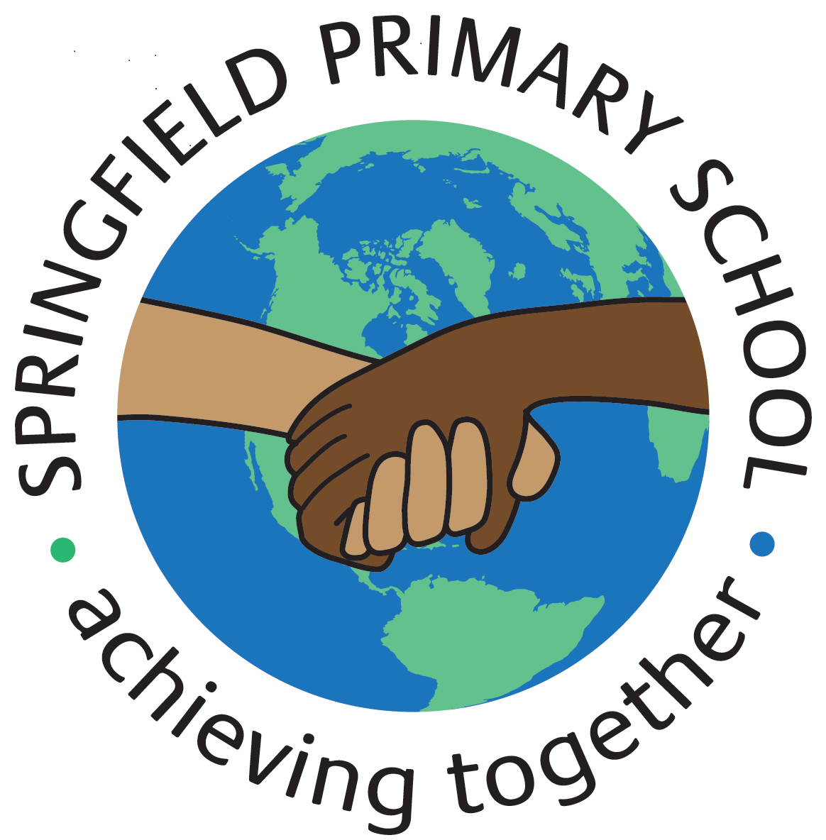
Half Term Curriculum Plan
Term: Autumn 1 2023 |  | Theme: Crime and Punishment
Key Questions:  How has crime and punishment changed in time since the Romans to today?  How was crime detected, criminals tried and punished in Romans times?  What was the most common crime in the Saxon/ Viking world and how would it be punished?  How were criminals caught in the medieval period?  What were the major changes in the way crimes were punished? |  | Stimulus: (Book/ Visit/ etc.)  Text:  The Highwayman by Alfred Noyse  Various Robin Hood texts  Visit to Sherwood Pines – Monday 2nd October 2023
As Writers we will:  Fiction:  Write narrative poem based on The Highwayman  Write diary entries from the perspective of a character  Write own adventure story based on various Robin Hood texts  Non-Fiction:  Write a non-chronological report |  | As Artists we will:  *discuss the effect of light and dark on an object.  *use colour and tone to show 3D form  *evaluate the context and intention of street art  *understand how art can tell stories or portray messages | As Designers we will:  N/A | As Computer Engineers we will:  *explain the importance of internet addresses  *explain how sharing information online can help people to work together  * explain how sharing information online can help people to work together  *recognise how we communicate using technology  *evaluate different methods of online communication
As Mathematicians we will:  *read and write numbers to 10,000,000  *compare and order any integers  *round any integer  *work with negative numbers  *add & subtract integers  * understand rules of divisibility  *multiply up to a 4-digit number by a 2-digit number  *understand written methods of short & long division |  |  |  | As Musicians we will:  *Identify the musical style of a song using some musical vocabulary to discuss its  Musical Elements
 |  | As French speakers we will:  *learn words for items in a classroom  *learn words for prepositions to be able to where something is located  *pronounce the phoneme ‘ai’ accurately  *revise parts of the irregular verb’ aller’  *learn how to form the simple future tense. |  | As Scientists we will:  *classify living organisms  *understand the kingdoms of life  *explain how different organisms can be classified using the Linnaean system  *identify the characteristics of different types of microorganisms  *investigate asexual reproduction through spore dispersal  *classify and describe a living organism
As Geographers we will:  N/A | As Historians we will:  *explore crime and punishment in the Roman, Anglo-Saxon and Viking, Medieval and Tudor and Victorian periods and compare it to today | As Sportspeople we will:  *develop bowling under pressure whilst abiding by the rules of the game  *strike a bowled ball with increasing consistency.  *make decisions about where and when to send the ball to stump a batter out.  *develop a variety of fielding techniques and when to use them in a game.  *develop long and short barriers in fielding and understand when to use them.  *apply skills and knowledge to compete in a rounders tournament. |  | As learners of Religion we will:  *consider how stillness and silence help us to learn  *explore how breathing exercises help us to stay calm  *understand how a tensing exercise can lead us to better imagination  *understand what Sikhs think about the value of money  *understand what Muslims think about the beauty of nature  In RSHE we will:  *understand what prejudice is  *explore the history of prejudice  *know what to do if we encounter prejudice  *Know how we can be great citizens

