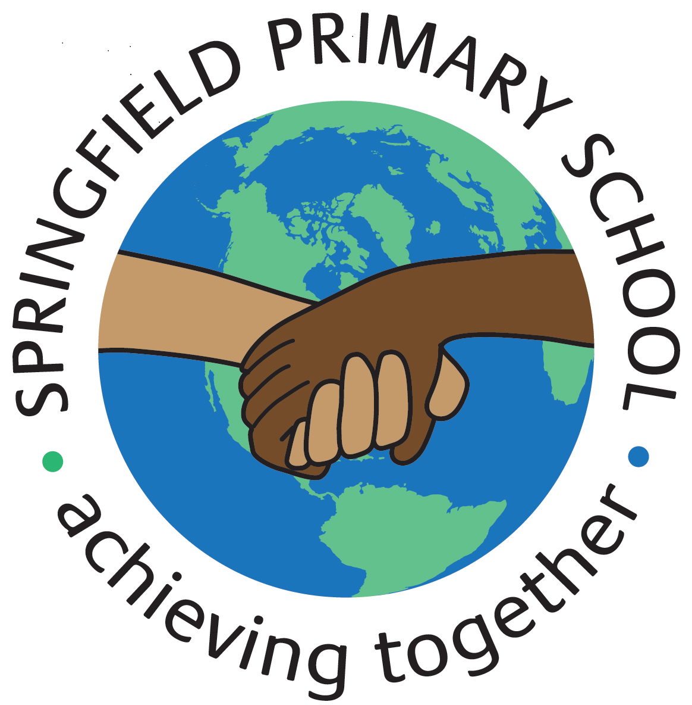
Half Term Curriculum P{an
Term: Autumn 1 2023 |  | Theme: Megacities
Key Questions:  - What is really lurking in the drain?  - What do we know about Ruskin?  - How would you describe Lizard Street?  - What is your idea of a hero?  Why is Ruskin a hero? |  | 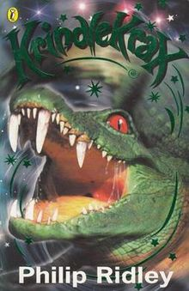  Stimulus: (Book/ Visit/ etc.) Library Visit  Children’s Book Award  Text: Krindlekrax by Philip Ridley
As Writers we will:  Explore a character in a narrative, as well as describe other characters and settings. We will write a non-chronological report about Crocodiles.  Plan and write a persuasive letter. |  | As Artists we will:  No Art this half term | As Designers we will:  Explore, Design, Make and Decorate Pneumatic toys. | As Computer Engineers we will:  Develop our understanding of digital devices, with a focus on input processes and output processes.
As Mathematicians we will:  Represent numbers from 1 – 100  Use a number line and partition numbers to 100  Represent numbers to 1000  Partition numbers to 1000  Place Value hundreds, tens and ones  Estimate, compare and order numbers to 1000  Count in 50s |  |  |  | As Musicians we will:  Learn to play the violin  Sing, play, improvise and compose Reggae songs.
 |  | As French speakers we will:  Practice and learn numbers from 1-10  Be able to say our age  Be able to say I would like |  | As Scientists we will:  Investigate and identify that humans and some other animals which have skeletons and muscles for support.
As Geographers we will:  Investigate why so many people live in megacities. (A very large city) | As Historians we will:  No History this half term | As Sportspeople we will:  Learn how to track a ball, throw and dribble a ball. (Outdoor)  Learn how to play Tag Rugby (Indoor) |  | As learners of Religion we will:  Learn about the journey of life and death  In RSHE we will:  Discuss Community Online Safety

