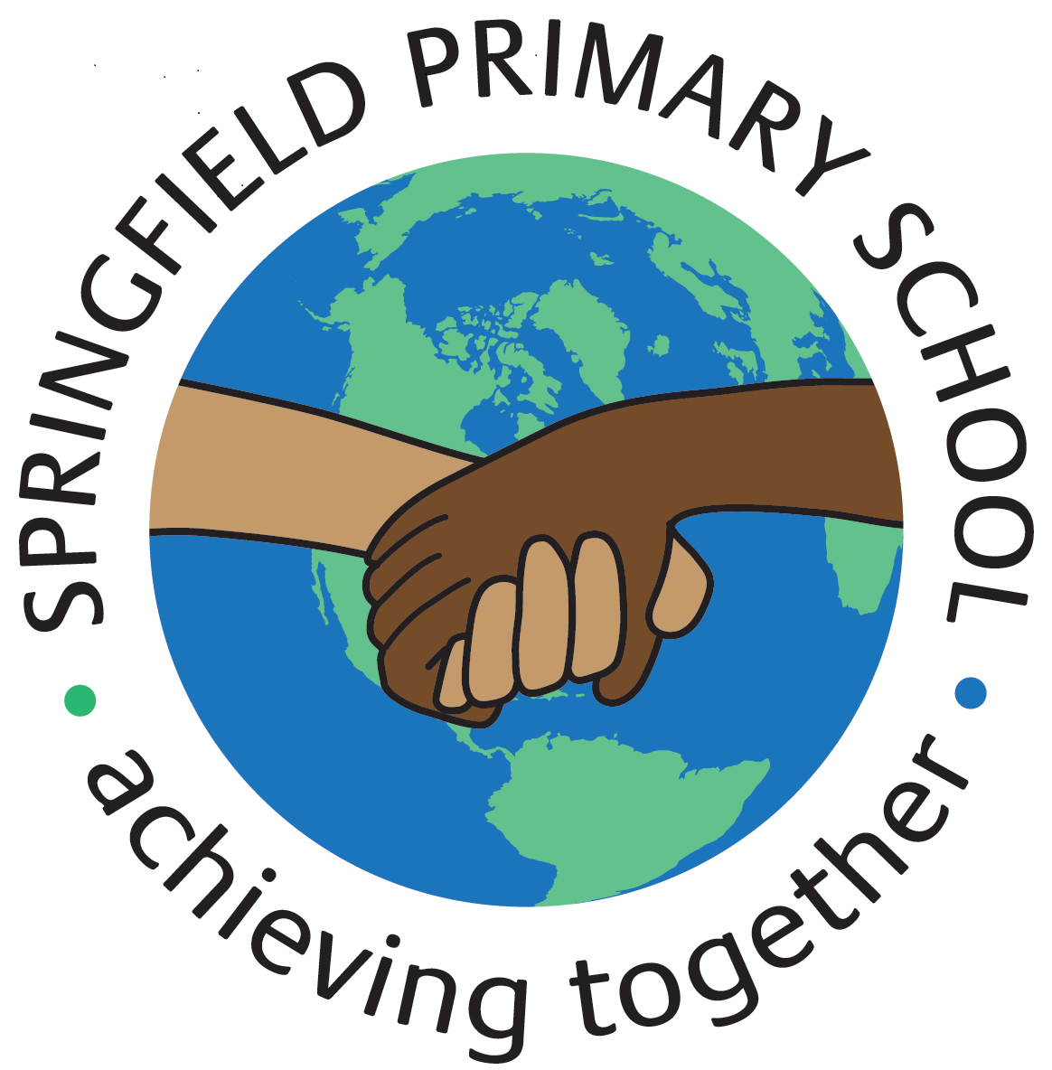
Half Term Curriculum Plan
Term: Autumn 1 2023 |  | Theme: Ancient Egypt
Key Questions:  - Why did people settle in Ancient Egypt?  - What sort of food did Ancient Egyptians eat and where did it come from?  - How and why did Ancient Egyptians mummify their dead? Why was writing important to the Ancient Egyptians? Would you like to live as Ancient Egyptian, and why? |  | Stimulus: (Book/ Visit/ etc.)  Fiction:  Flat Stanley and the Great Egyptian Grave Robbers  Non-Fiction:  DK find out! Ancient Egypt; making mummified apples; various non-fiction information texts.
As Writers we will:  Fiction:  - Study the structure and build-up of a narrative, including scene-setting, character description, mini-problems, utilising speech to create pace and clues to what might happen next in the story  - Compose our own interesting and exciting Egyptian adventure stories and begin to proofread and edit our compositions  Non-Fiction:  - Explore the features of instruction writing  - Write our own instructions which include what, how, why, when and where |  | As Artists we will:  - Investigate the style, pattern and characteristics of Ancient Egyptian art  - Apply understanding of ancient techniques to construct a new material  - Apply drawing and painting skills in the style of the Ancient Egyptians | As Designers we will:  N/A | As Computer Engineers we will:  - Describe the Internet as a network of networks  - Describe networked devices and how they connect  - Explain the types of media that can be shared on the WWW  - Describe how content be added and accessed on the WWW.  - Recognise that the content of the WWW is created by people  - Suggest who owns the content on websites  - Explain that not everything on the WWW is true
As Mathematicians we will:  - Represent numbers to 10,000 and partition numbers to 10,000  - Find 1, 10, 100 and 1,000 more or less  - Estimate on a number line to 10,000  - Compare and order numbers to 10,000  - Learn and use Roman numerals  - Round to the nearest 10, 100 and 1,000  - Be able to calculate or recall number bonds to 100. |  |  |  | As Musicians we will:  - Listen to a song / appraise a song / learn a song / perform a song: ABBA
 |  | As French speakers we will:  - Learn dates, times and greetings  - Practise spelling and pronouncing colours |  | As Scientists we will:  - Identify and name parts of the Digestive System  - Explain the function of different parts of the Digestive System  - Identify different types of teeth and explain their different functions  - Draw a bar chart to show how many of the different types of teeth I have  - Plan and carry out a scientific enquiry.
As Geographers we will:  N/A | As Historians we will:  - Draw a timeline and describe the main events of Ancient Egyptian civilisation from 6,000 BC to 332 BC  - Explain what a pharaoh was and the role they played in Ancient Egyptian society | As Sportspeople we will:  Outdoors: Rounders  - Develop underarm and overarm throwing techniques  - Develop bowling and fielding techniques.  Indoors: Swimming  - Learn to swim competently and confidently over a distance of 25m  - Use a range of strokes effectively, such as front crawl and back stroke and perform safe self-rescue techniques in different situations. |  | As learners of Religion we will:  - Explain the role of pilgrimage  - Compare and contrast different pilgrimages  In RSHE we will:  - Learn what makes a good friend  - Learn if all friends are the same  - Learn about getting on and falling out

