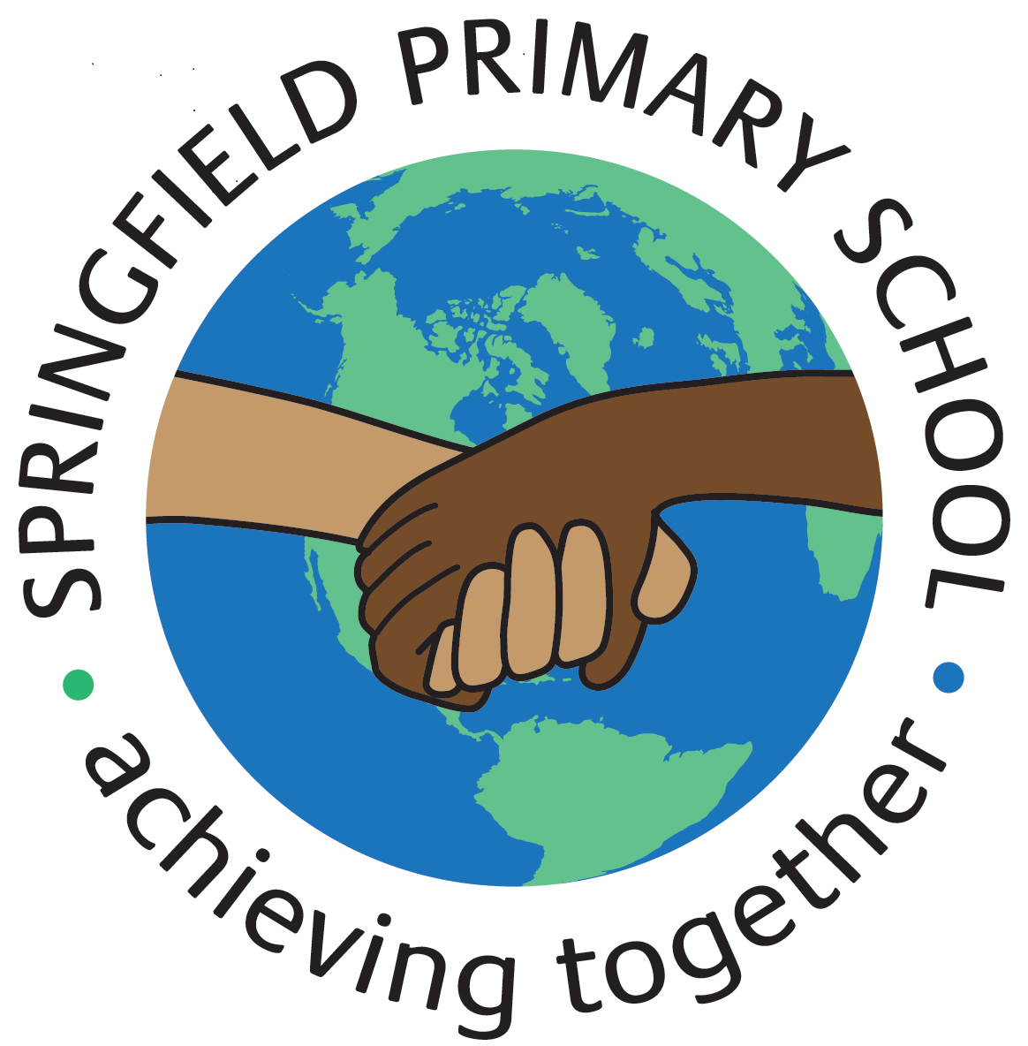
Half Term Curriculum Plan
Term: Autumn 2 |  | Theme: The Iron Man
Key Questions:  - Are all monsters bad?  - What makes people good or bad?  - What causes different behaviour? |  | Stimulus:  Text: The Iron Man by Ted Hughes  In groups, children will design models of the Iron Man, complete with light-up eyes. This will be used a stimulus for writing.  Children are asked to bring in cardboard cereal boxes (or similar) and other materials from home – please save your card cereal boxes for Week 4.
As Writers we will:  - Read a range of newspapers  - Investigate the key features of newspaper articles  - Role-play as newspaper reporters interviewing people at the scene of an incident  - Learn how to lay out our writing in the style of a newspaper front page  - Write using direct quotes from our interviews alongside using reported speech  - Write an independent newspaper article  - Investigate homophones. |  | As Artists we will:  N/A | As Designers we will:  - Learn about how electrical products work  - Analyse and evaluate electrical products  - Design a product to meet a specific set of specific user needs  - Make and evaluate an Iron Man head desk lamp | As Computer Engineers we will:  - Explain that sound can be recorded  - Explain that audio recordings can be edited  - Recognise the different parts of creating a podcast project  - Apply audio editing skills independently  - Combine audio to enhance a podcast project  - Evaluate the effective use of audio.
As Musicians we will:
- Listen to a song / appraise a song / learn a song / perform a song: Stop!
- Listen to Gotta Be Me, Radetzky March by Strauss, Can’t Stop The Feeling, Libertango by Astor Piazallo and Mas Que Nada by the Black-Eyed Peas
As Mathematicians we will:
- Investigate area by counting squares, making shapes and comparing areas of shapes
- Learn multiples of 3
- Multiply and divide by 6; multiply and divide by 9
- Multiply by 1 and 0
- Divide a number by 1 and itself
- Multiply three numbers.
 |  | As French speakers we will:  - Learn about French adjectives  - Learn about food  - Learn how to give an opinion about food  - Learn how to shop for food in French |  | As Scientists we will:  - Make simple circuits and test to see if a material is an electrical insulator or conductor  - Make a variety of switches  - Apply knowledge of circuits and electricity to make an Iron Man head desk lamp (links with DT).
As Geographers we will:  - Explain what sustainability means  - Draw up an action plan to help the school become more sustainable  - Learn how wind turbines and solar panels generate electricity. | As Historians we will:  N/A | As Sportspeople we will:  Indoors:  - Copy and create actions; choose actions that relate to a theme  - Develop dance using matching and mirroring  - Develop a dance phrase to use as part of a class performance  Swimming  - Learn to swim competently and confidently over a distance of 25m  - Use a range of strokes effectively, such as front crawl and back stroke and perform safe self-rescue techniques in different situations. |  | As learners of Religion we will:  - Learn how people express their religious and spiritual ideas on pilgrimages  - Explain what Muslims believe about pilgrimages  - Present the main events of the Hajj  - Explain what Jews believe about pilgrimages  - Explain why pilgrimages are special  In RSHE we will:  - Learn about keeping friendships healthy  - Ask are friendships always fun?

