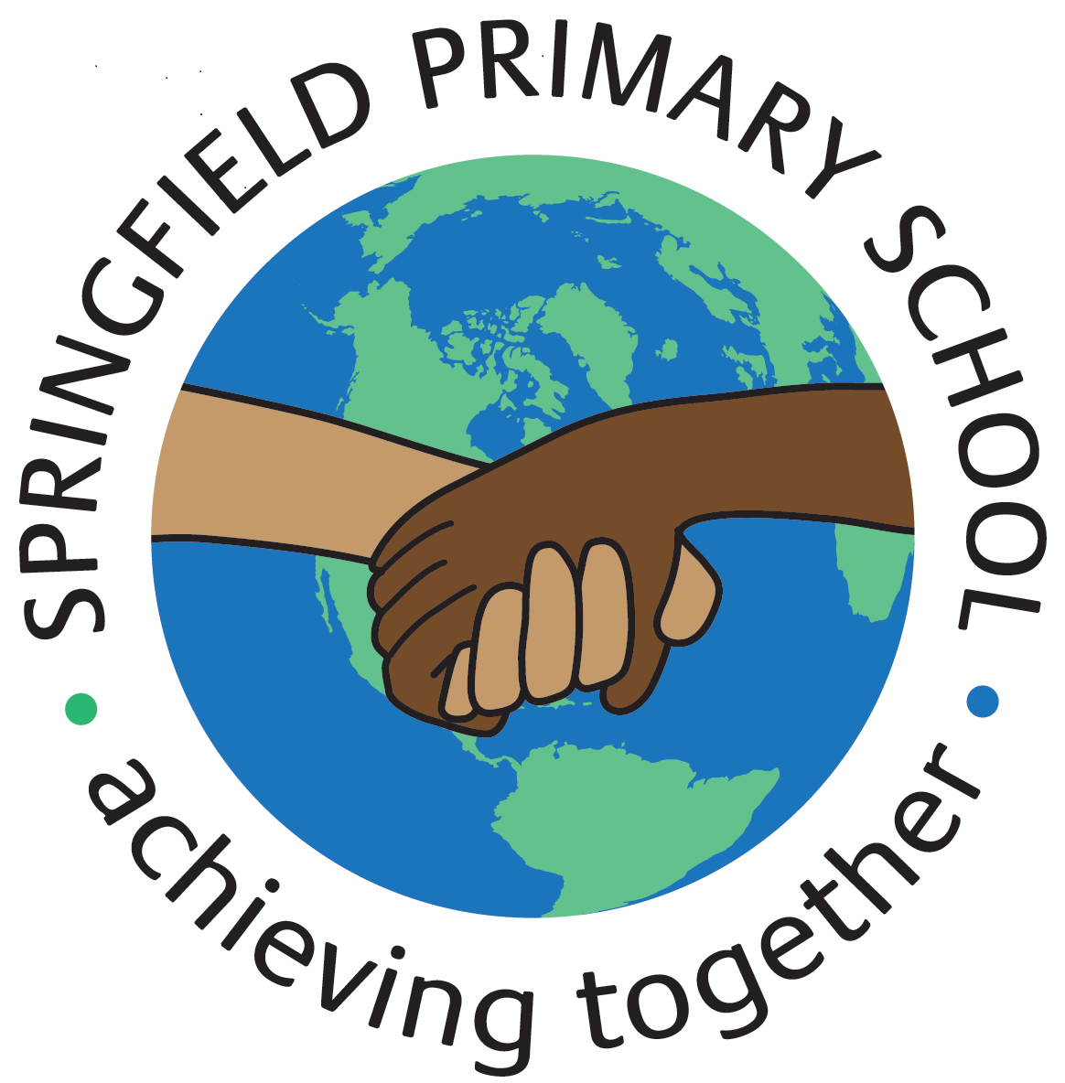
Half Term Curriculum Plan
Term: Spring 2 2024 |  | Theme: Kingdom of Benin
Key Questions:  Where was the kingdom of Benin? When was this period of time?  How do we know about periods of history without primary written sources?  What were the first kings of Benin like? What can the bronze artefacts of Benin tell us?  What did Benin have to offer foreign traders?  When was the ‘Golden Age of Benin’ and why was it called this?  When, why and how did the Benin Empire begin to decline? |  | Stimulus: (Book/ Visit/ etc.) Sheffield Children’s Library – Thursday 22nd February 2024  Sports Volunteers from Sheffield University – Friday 23rd February 2024  Halle Orchestra – Friday 8th March 2024  Text:  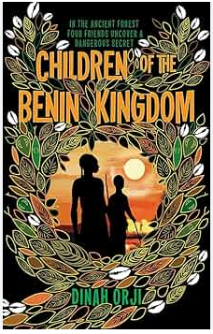
As Writers we will:  Develop our use of grammatical features including:  *parenthesis  *relative clauses  *apostrophes for contraction and possession  Fiction: write to inform through an informal letter.  Non-Fiction: write to inform through a non-chronological report about the historical Benin Kingdom. |  | As Artists we will:  Not studied this Half Term | As Designers we will:  *prepare wood for assembly by measuring, marking and cutting each piece.  *assemble automata frame components and supports with the help of an exploded-diagram.  *explore the relationship between cam profiles and follower movement.  *apply the housing and finishing touches to an automata frame. | As Computer Engineers we will:  *create a data set in a spreadsheet.  *build a data set in a spreadsheet.  *explain that formulas can be used to produce calculated data.  *apply formulas to data.  *create a spreadsheet to plan an event.  *choose suitable ways to present data.
As Mathematicians we will:  *develop our understanding of place value – integers and decimals  *round decimals  *add and subtract decimals  *multiply and divide by 10, 100 and 1,000  *multiply and divide decimals by integers  *identify decimal and fraction equivalents  *understand percentages  *order fractions, decimals and percentages |  |  |  | As Musicians we will:  *play instrumental parts accurately and in time.  *compose a melody using simple rhythms.
 |  | As French speakers we will:  *make comparisons using adjectives.  *revise comparatives.  *talk about our favourite house/ hobby/ subject.  *appreciate a story and understand the main points. |  | As Scientists we will:  * understand the function of the heart and its role in the circulatory system.  *identify and compare blood vessels.  *explore blood.  *learn how the body transports water and nutrients.  *investigate what affects our heart rate.  *learn about the impact of drugs and alcohol on the body.
As Geographers we will:  Not studied this Half Term | As Historians we will:  *study a non-European society that provides contrasts with British history –  Benin (West Africa) c. AD 900-1300. | As Sportspeople we will:  *combine and perform gymnastic shapes more fluently and effectively.  *explore counter balance and counter tension.  *develop fluency and consistency in the straddle, forward and backward roll.  *combine and perform a range of gymnastic jumps more fluently and effectively.  *send and receive using a range of techniques with increasing control  *dribble using a range of techniques with increasing control under pressure.  *transition from attack to defence or defence to attack.  *confidently change direction to lose an opponent. |  | As learners of Religion we will:  *discuss the contributions religions make to local life in Sheffield.  *think how we can make Sheffield a city of tolerance and respect.  In RSHE we will:  *discuss why some people take drugs.  *understand where we should get our health information.  *research how to save a life?

