Springfield Primary School.
Year 3
Term: Spring 1 2024 | Theme: Stone Age to Iron Age
Key Questions  What were the changes in Britain from the Stone Age to the Iron Age?  How did life change for Ancient Britons during the Stone Age? | Stimulus: (Book/ Visit/ etc)  Text: Stone Age Boy by Satoshi Kitamura Ug by Raymond Briggs  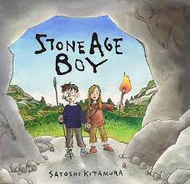
As writers we will:  Be writing to inform our readers by writing  Instructions  Writing for ourselves by writing  Diary entries. | In Religious Education we will:  Investigate why some people think life is a journey. |  | In computing we will:  Explore sequencing and programming through the programme Scratch.
As mathematicians we will:  Recall and use our multiplication and division facts to solve practical problems.  We will also look at how we can multiply a 2-digit number by a 1-digit number and look at how we can divide a 2-digit number by a 1-digit number. | As designers we will:  Investigate where in the world our food comes from? |  | As historians we will:  Investigate and learn how life changed for Ancient Britons during the Stone Age?
 | As French speakers we will:  Know and name animals and body parts. |  | As musicians we will:  Practise our skills in playing the violin
As scientists we will:  Describe in simple terms how fossils are formed when things that have lived are trapped within rock  Recognise that soils are made from rocks and organic matter | In RSHE we will:  Look at our physical health and find out different ways of keeping our bodies healthy. | As artists we will:  Not covered  this half term | In PE we will:  Learn to create actions in response to a stimulus and move together with a partner

