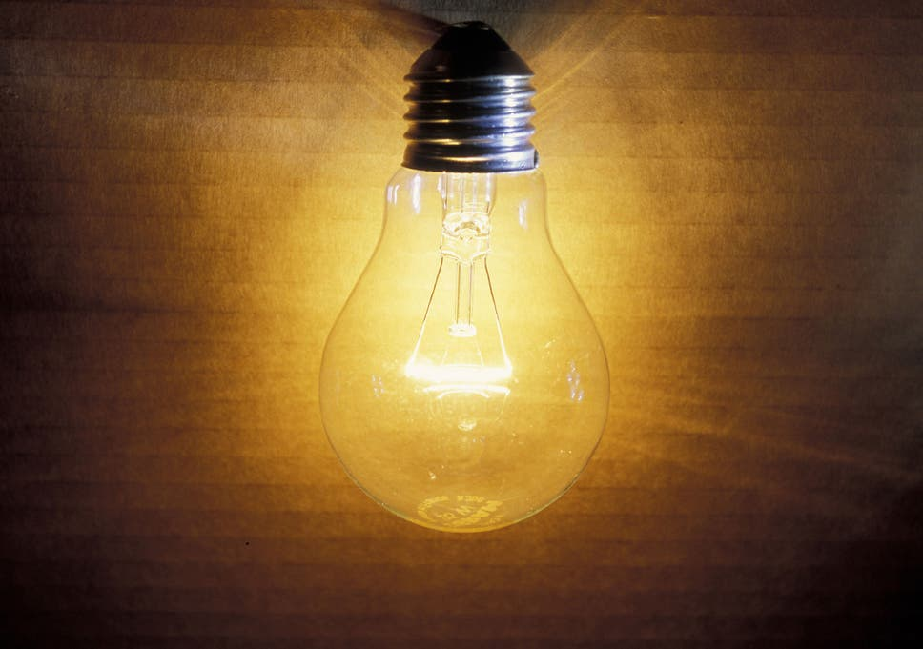
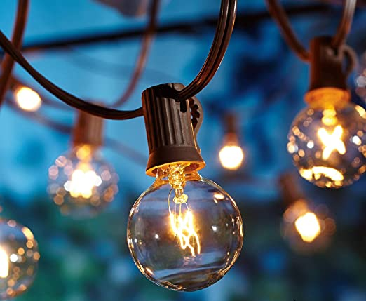

Light

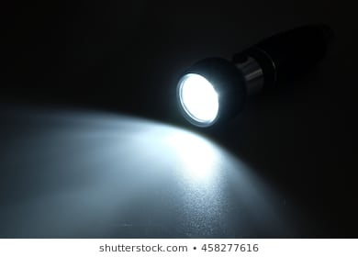
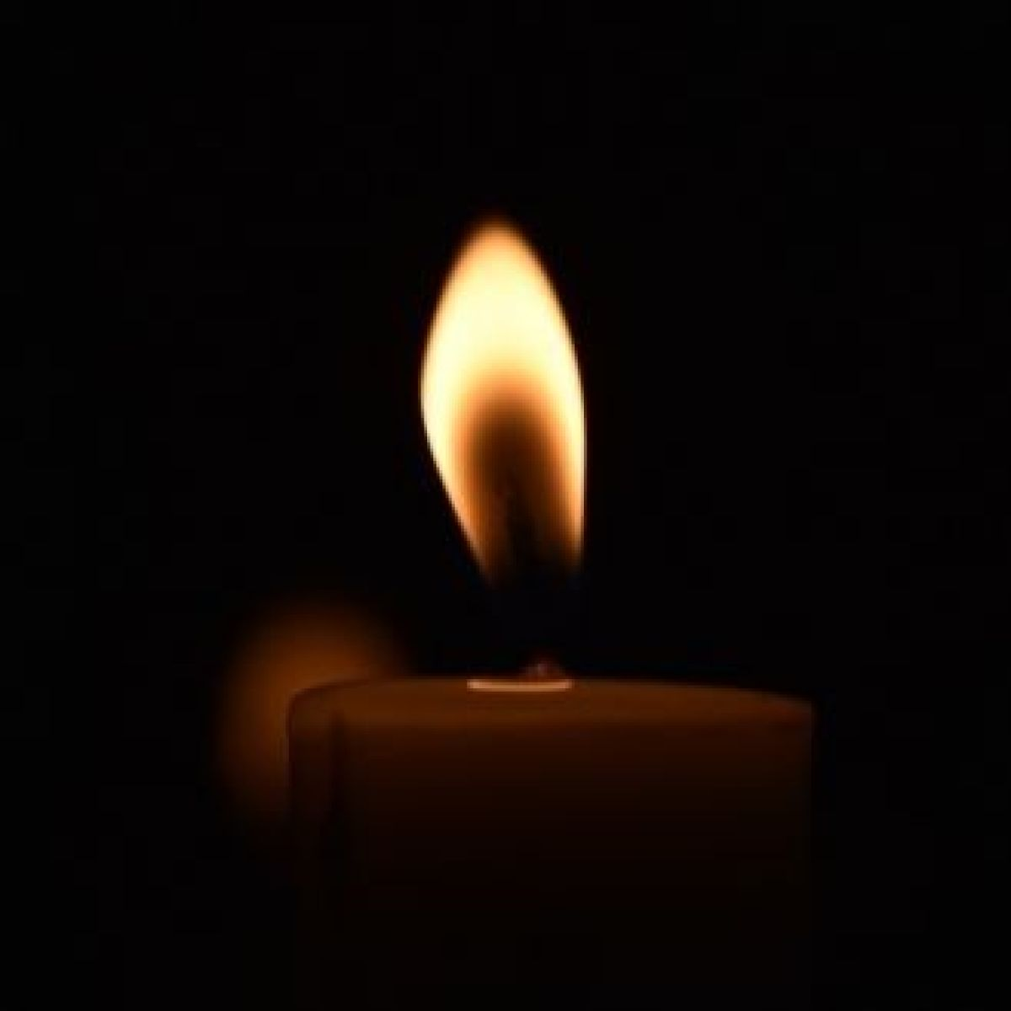

Y5/6B Autumn 1, 2020

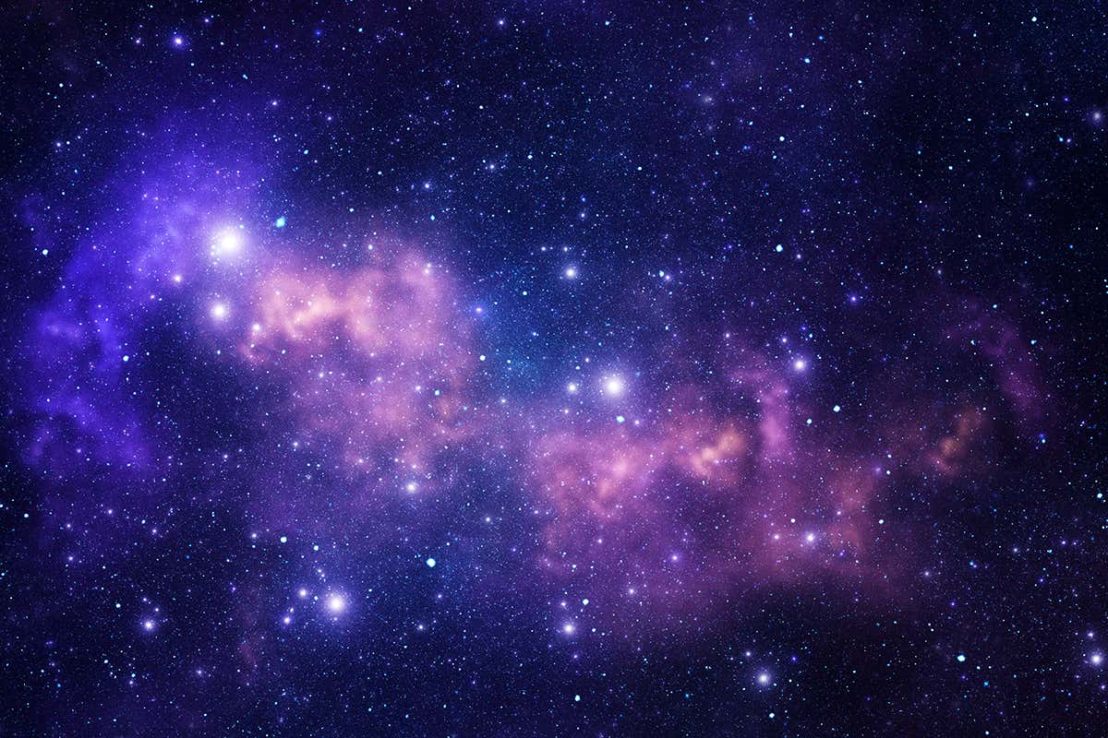
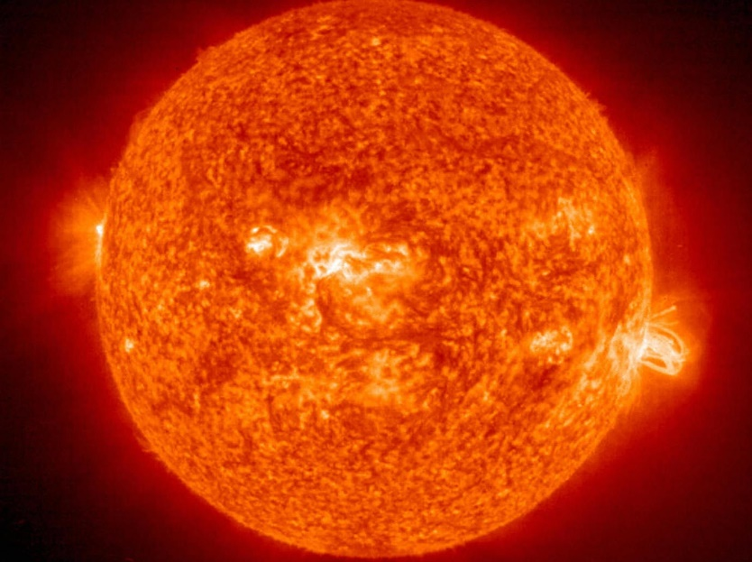

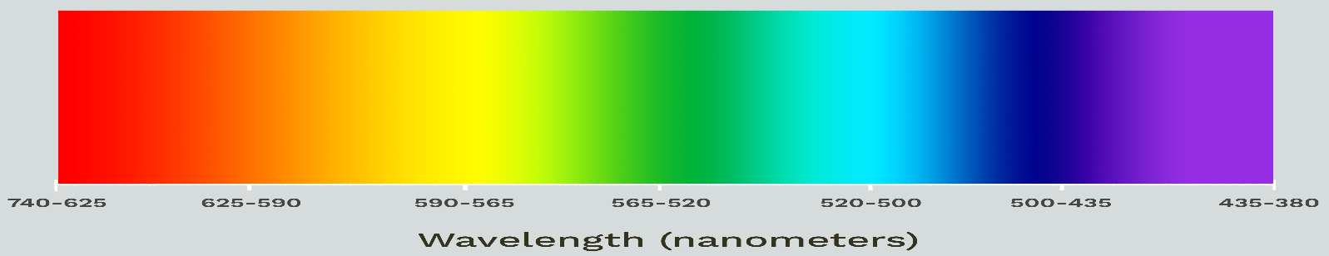

Science

Light
Pre-Topic Assessment
Task 1

You have 10 minutes to write everything you can think of to do with ‘light’. Use a pencil. GO!

Pencil: Pre-Topic Assessment Green Pen: Post-Topic Assessment

 | Week 2 |  |  |  | Lesson 1

Miss. Button says says:
Have you done your Pre-Topic Assessment? Good.

I wish I was teaching you about sound in school, but we’ll just have to try to do our best at home. Here we go.
Task 2

Copy this sentence on to the blue lines:
We see objects when light rays hit them, bounce off and travel into our eyes. ______________________________________________________________________________________

A light source is anything that makes light. ______________________________________________________________________________________
Task 3

Type this into Google

Watch this clip.

Task 4

Watch the video again then try to explain to a grown-up facts about light. Make sure you use these key words when you explain.

opaque transparent translucent travel particles wave
vibration air molecules sound wave travel medium ear
 | Week 3 |  |  |  | Lesson 2
Task 5

Now...

You have 30 minutes to look around your home or outside and find different light sources

Remember a light source is anything that makes light.

Draw and label each object that can make light. Get ready... GO!

1  The Sun | 2 | 3
4 | 5 | 6
7 | 8 | 9
10 | 11 | 12
13 | 14 | 15

Recap question: What is a light source?

 | Week 3 |  |  |  | Lesson 3

Science: Light

Miss. Buttin says says:

When light hits an object, different things can happen.

When the surface is smooth, like a mirror, reflected light rays travel in the same direction.

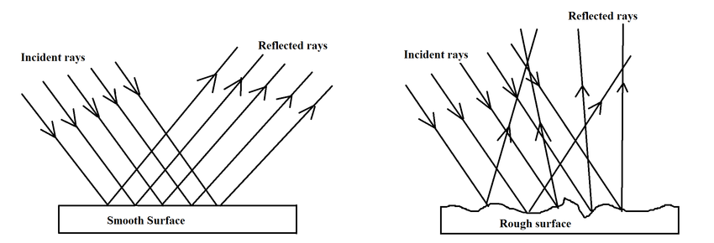
When the surface is rough, reflected light travels in lots of different directions.
Task 1
Type this into Google

Watch this clip.

- It will show you what happens when light hits a mirror. You could try this at home as well. Just use a torch instead.
- I would Like you to explain what happens in the video. Could you explain what light reflection is and describe how it would look using a smooth surface?
 | Week 4 |  |  |  | Lesson 4

Science: Light

Here is another experiment that you can do at home to see how reflection works:

Materials for Mirror Reflection Science
- At least 2 mirrors (Preferably one on a wall and one you can hold)
- Some words and letters to study in the mirror
- Pencil and paper

Procedure for Mirror Reflection Science
1. Explore what happens with two mirrors facing each other.
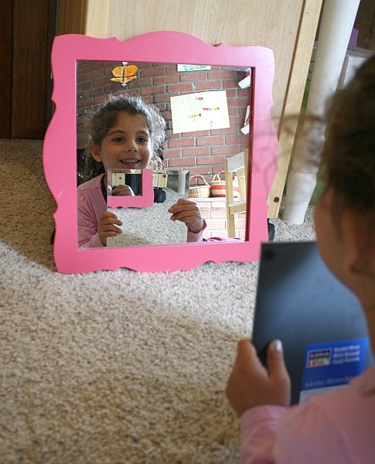
- Prop a mirror against a wall and hold the other mirror in front of you. What happens to your reflection? Can you see more than 2 of you? Make sure you record your observations.
- Why does it do that?
- Make a prediction… maybe it might be that your reflection kept bouncing back and forth inside the mirror.
- Now can you find out why this happens?

Answer:
You see yourself in a mirror because light bounces off you, hits the mirror, and then reflects back into your eyes. When you add another mirror into the equation, light bounces off one mirror and hits another mirror so you’re seeing a reflection of a reflection. Because the two mirrors are facing each other, you’re getting a reflection of a reflection of a reflection etc.

 | Week 4 |  |  |  | Lesson 5

Science: Light
Task 1

Find a place in your home. Sit down on the floor and look around the room. What can you see?

Try different areas of your home. You can even try outside. Write down everything you can see in the table below.
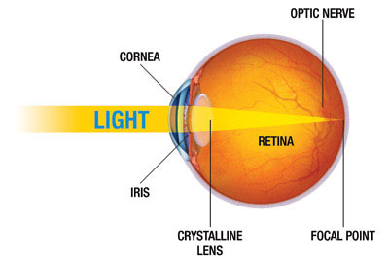
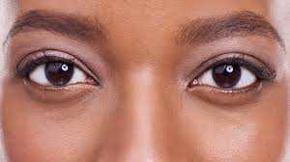

What can you see?

Where: Kitchen |  | Where:
Fridge
Where: |  | Where:

I saw these objects because light hit them, bounced off the objects and entered my eye. ____________________________________________________________________________________________

