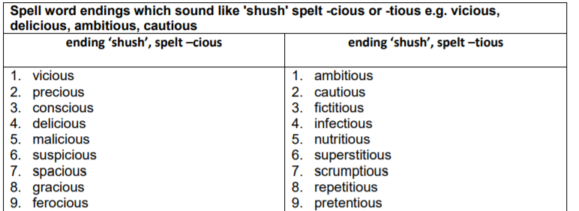

- Have a go at spelling these words… Remember to Look, say, cover, write and check.
- Use a dictionary or enter the words into google so that you can find out what they mean
- Can you put these words into sentences?

