Icarus and Daedalus
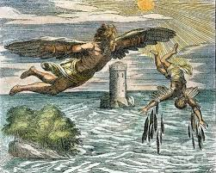
Read the story in the folder. Then, retell it in your own way. Create your own narrative, a diary entrée. Anything you can think of to retell the story.

