
Learning Objective
We are learning how to use prepositions to express time, place and direction.

Challenge 1
Complete the following sentences by choosing the most appropriate time, place or movement preposition from the list below:
around
through
beside
before
after
across
on

- The impressive big cat prowled __________ the undergrowth.
- The powerful leopard was spotted swimming _________ the Mara River.
- _________ continuing her journey, the leopard marked the tree with her claw.
- Inside the cave, two cubs were lying ________ their protective mother.
- The rescued leopard cub padded __________ its cage.
- ________ filling its belly with a warthog, the leopard rested ____ the branch.

Challenge 2
Using a preposition from the list below, write a sentence about each image that explains where the leopard was in relation to its surroundings.
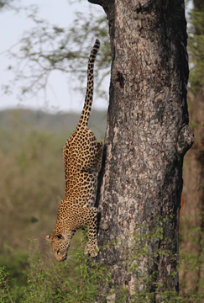

behind
beneath
inside
beyond
over
along
next to
amongst

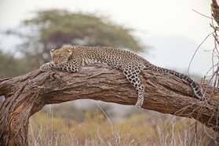
- _____________________________________________
_____________________________________________

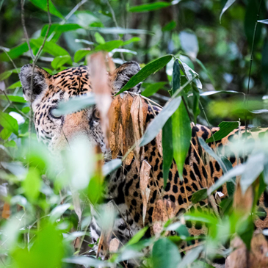
- _____________________________________________
____________________________________________
Snow leopard

- ______________________________________________
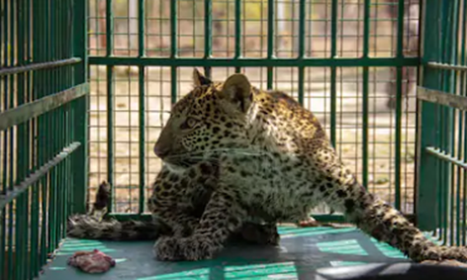
______________________________________________

- ______________________________________________
______________________________________________
won’t
won’t
won’t
Snow leopard
territory
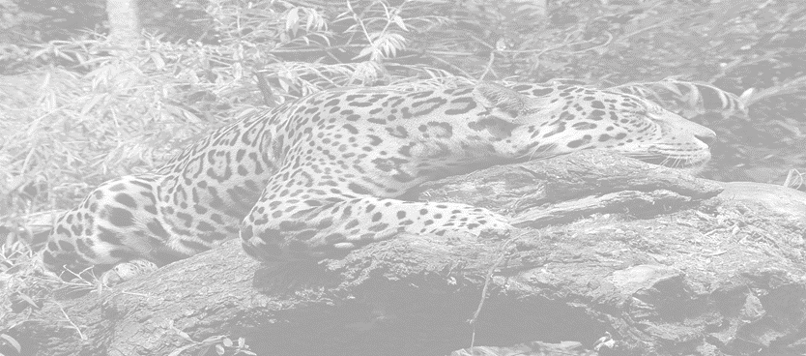
.
behind
near
ambushed
inside
before
during
muscular
secretive
dragged
towards
pounced
Challenge 3
Using some of the prepositions and descriptive words from the Word Wall, write your own scintillating sentences about the leopards featured in the film clip
Word Wall

