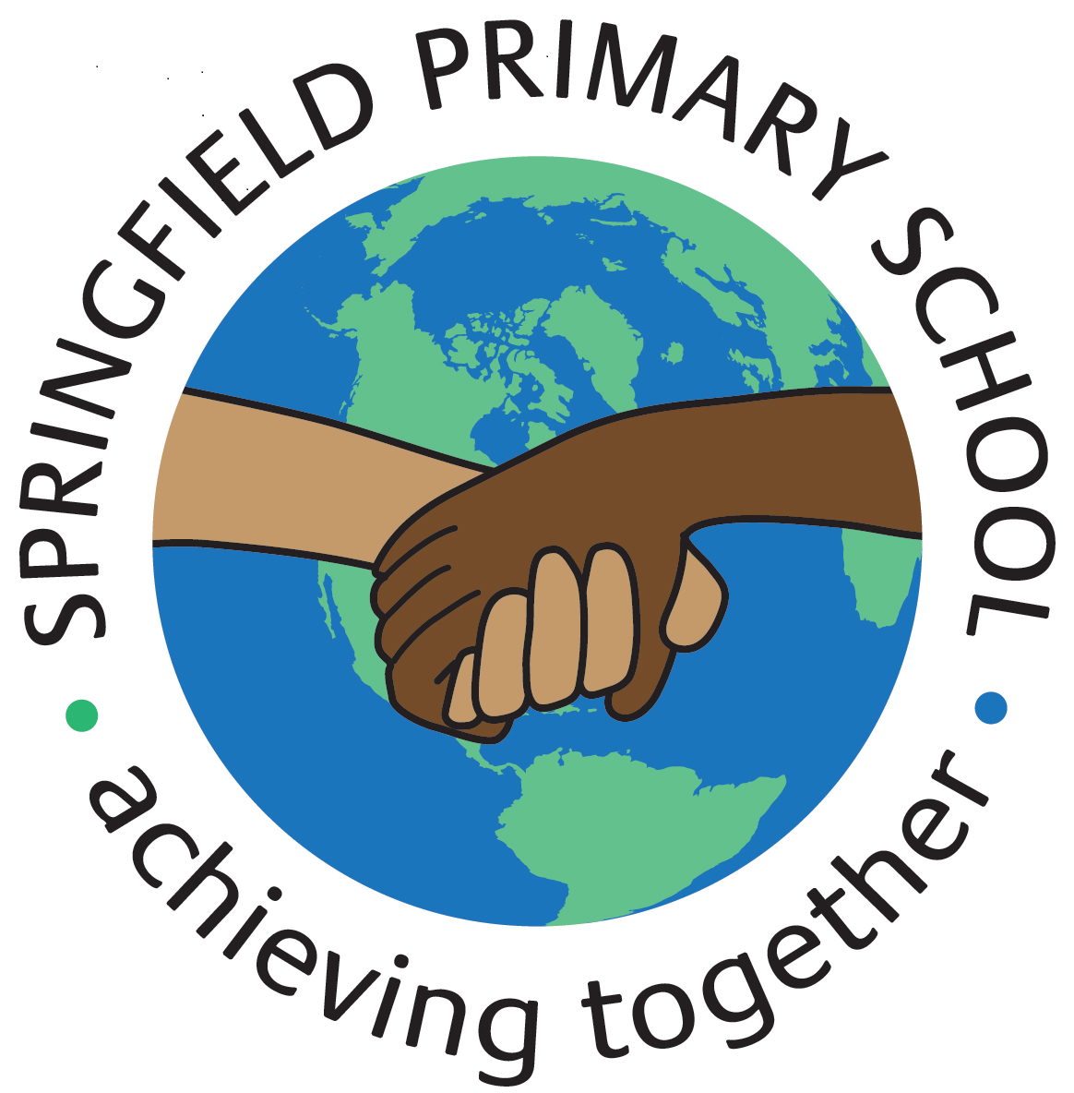**Half Term Curriculum P{an**

|  |  |  |
| --- | --- | --- |
| **Term:** Spring 1 | **Theme: Earth and Space** | |
| **Key Questions:**   * What evidence is there to prove that the Earth spins around? * What if… one of the planets was hit by a meteorite; all the planets aligned together; if the sun burned out? * What would happen if the Earth stopped spinning? | **Stimulus: (Book/ Visit/ etc.)** Visit the National Space Centre in Leicester  **Text:**   * One giant leap – The story of Neil Armstrong. - Don Brown * Various Non-fiction texts about Space and the Solar System. | |
| **In writing, we will:**  Write to inform by teaching our readers about a planet of our choice by producing a non-fiction information text. We will write to inform our readers about the life of Neil Armstrong by writing a biography.  **In Spelling, Punctuation and Grammar (SPAG), we will:**  Be revising subordinate clauses extending onto commas to mark clauses. We will be organising information / ideas into paragraphs that link across the text. | **In Art, we will:**  Improve our mastery of art and design techniques using painting.  Paint a space themed picture in the style of the artist Peter Thorpe, using an abstract art background and a space feature in the foreground. | **In Geography, we will:**  Learn about how climate change is affecting the world. |
| **In Maths, we will:**  Learn formal Multiplication and division methods using numbers up to 4 digits by 2 digits.  Multiply fractions and find fractions of an amount. | **In French, we will:**  Perform simple calculations using vocabulary for numbers between 1-31 and mathematical vocabulary.  We will learn the verb ‘être meaning ‘to be. | **In Music, we will:**  Learn to sing the song: ‘Make You Feel My Love’ by Adele.  We will play along the song using tuned percussion instruments.  We will listen to and appraise other pop ballads. |
| **In Computing, we will:**  Control a simple circuit connected to a computer  Write a program that includes count-controlled loops |
| **In Science, we will:**  Be studying Earth and Space.  We will learn about the solar system and its planets. This will include a trip to the National Space Centre in Leicester. | **In Physical Education (PE), we will:**  Improve our dancing skills with a theme of Outer Space.  Learn how to play hockey, developing our attacking and defending skills and learning how to dribble with control. | **In Religious Education (RE), we will:**  Learn about why the Torah is so important for Jewish people.  **In Relationships, Social, Health Education (RSHE), we will:**  Learn about how to keep safe online. |