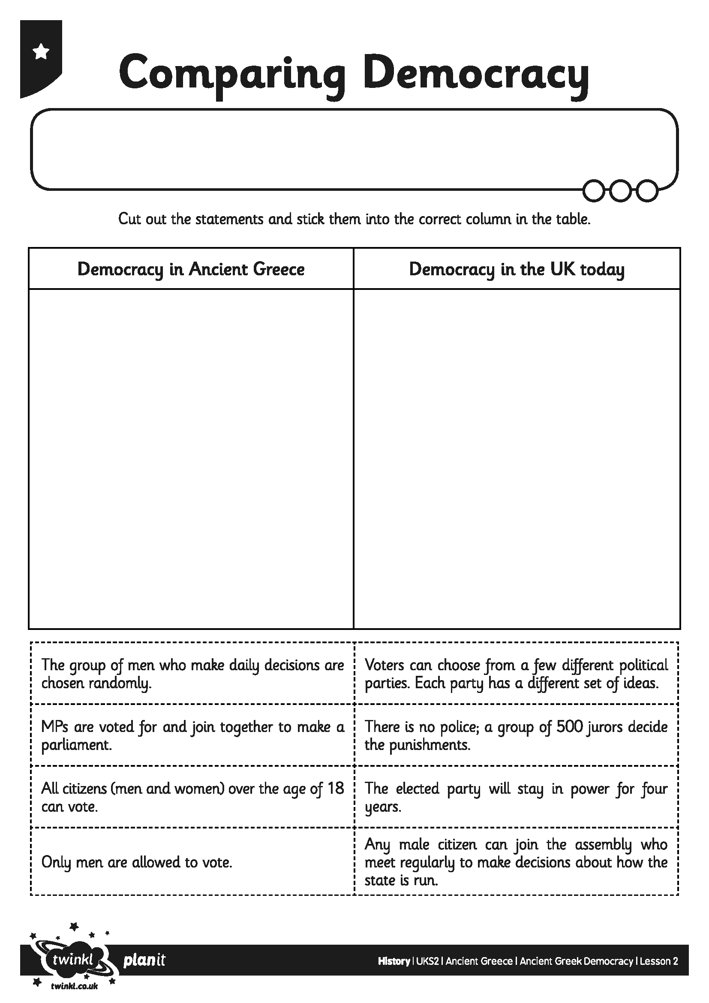
I can explain how the political system worked in Ancient Greece
I can compare this system with other political systems

