Spring 1: Week 3 w/c 18.01.21
Objectives

- I know the skills and attributes of an effective learner.

TASKS

Think of someone famous who you admire.
Use the following questions to share what you know about the person you have chosen.

- What has the person achieved?
- Why do you respect the person for this?
- What obstacles were in his or her way?
- How did he or she overcome them?
- Who helped the person achieve their goal?
- What do you think the person said/did when they felt like giving up?
- Is there anything that the person has done in achieving their goals that you think they should not have done?

List words to describe the qualities and attributes of the person.
You can write a small piece of writing explaining why you admire them.
These qualities can be used as aspirations or goals that you may then plan to achieve. You can use pictures too.

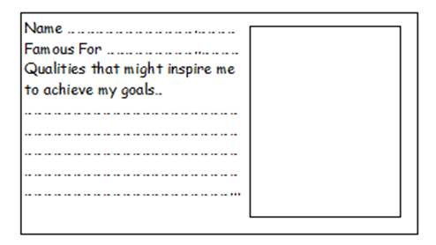Use the TASK sheet to help if you like

Outcomes
Listed qualities and you will have written a small report with a picture.

Notes

Powerpoint Lesson 2
TASK Sheet 2

