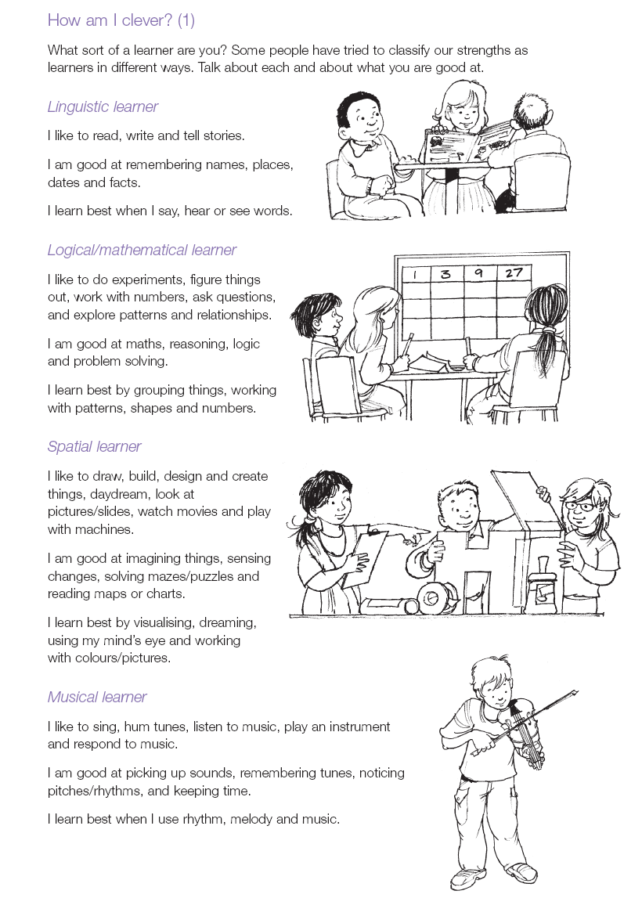

Which learning style are you?
Which learning style scored the highest?

Which learning style did you scored the least?

Have you more than one learning style?
If so, what are they?

